|  |
| --- |
| EPAM Systems, RD Dep. |
| Analysis of Milavitsa’s Sales |

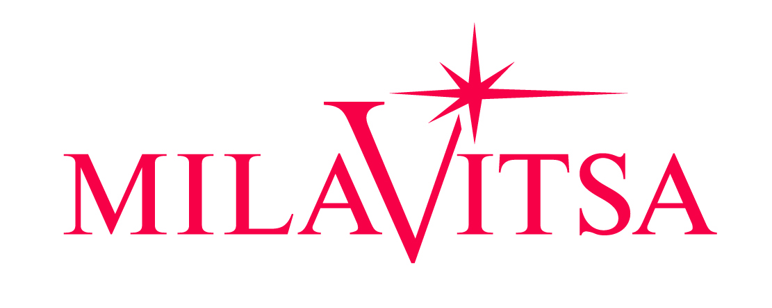

Contents

1. Business Description 3

1.1. Business background 3

1.2. Problems because of poor data management 3

1.3. Benefits from implementing a Data Warehouse 3

# Business Description

## Business background

For many years Milavitsa has been producing lady’s lingerie, being one of the biggest lingerie producer in Eastern Europe. The company's products are successfully sold in more than 25 countries around the world and are characterized by high quality, original and fashionable designs.

Company has four main brands:

1. **Milavitsa.**

The Milavitsa product portfolio includes bras, knickers, shapewear, knitwear and swimwear. The Milavitsa collection is divided into three categories: classic, fashion and swimwear. The basis of the classic collection is formed by a large variety of everyday styles, combining the basics of classical design, comfortable construction and functional materials. Milavitsa is an expert in creating the styles of large sizes. Fashion and swimwear collections are created for every season, following the fashion trends in design, materials and accessories.

1. **Avelive Collection.**

Bras, knickers, shapewear are also manufactured under the Aveline trademark. This is comfortable everyday lingerie at affordable prices. The Aveline products are developed and manufactured by Milavitsa, which is a guarantee of high quality and compliance with the company’s standards.

1. **Alisee.**

Alisee is a French lingerie brand acquired by Milavitsa. Alisee collection is designed and styled by European professionals. Tailored by Milavitsa to fit local market specifics.

1. **Hidalgo.**

The Hidalgo is men's underwear combines classic shapes and comfortable natural materials.

## Problems because of poor data management

Company faced next problems:

1. absence of business intelligence from several sources;
2. decreasing query and system performance;
3. absence of timely access to data;
4. absence of historical intelligence.

## Benefits from implementing a Data Warehouse

1. **Better decision-making.** Corporate decision makers will no longer have to make important business decisions based on limited data and hunches. Data warehouse will store credible facts and statistics, and decision makers will be able to retrieve that information from the data warehouse based on their personal needs.
2. **Quick and easy access to data.** Speed is an important factor that sets company above its competitors. Business users can quickly access data from multiple sources from a data warehouse, meaning that precious time will not be wasted on retrieving data from multiple sources. This allows company to make quick and accurate decisions, with little or no support from its IT department.
3. **Data quality and consistency.** Since data warehouses gather information from different sources and convert it into a single and widely used format, departments will produce results that are in line and consistent with each other. When data is standardized, company can have confidence in its accuracy, and accurate data is what makes for strong business decisions.